Name :SK.Kashifa

Registration no :192121135

Online stock management :

Class diagram :

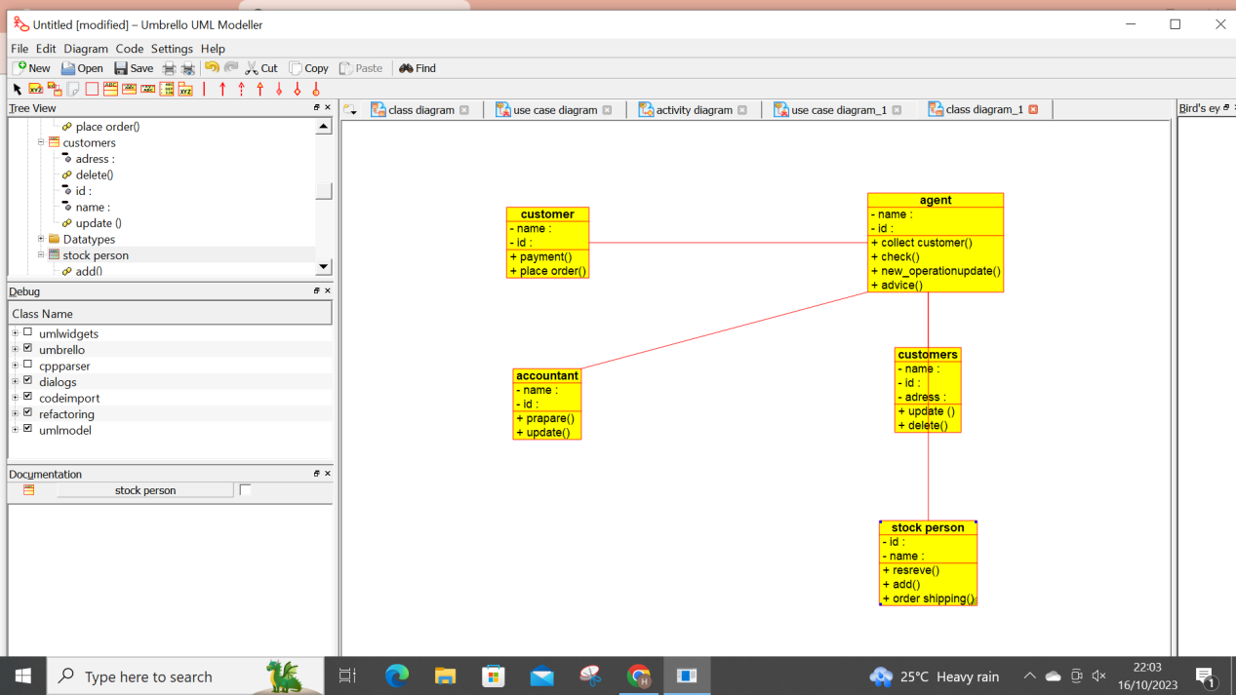

Usecase :

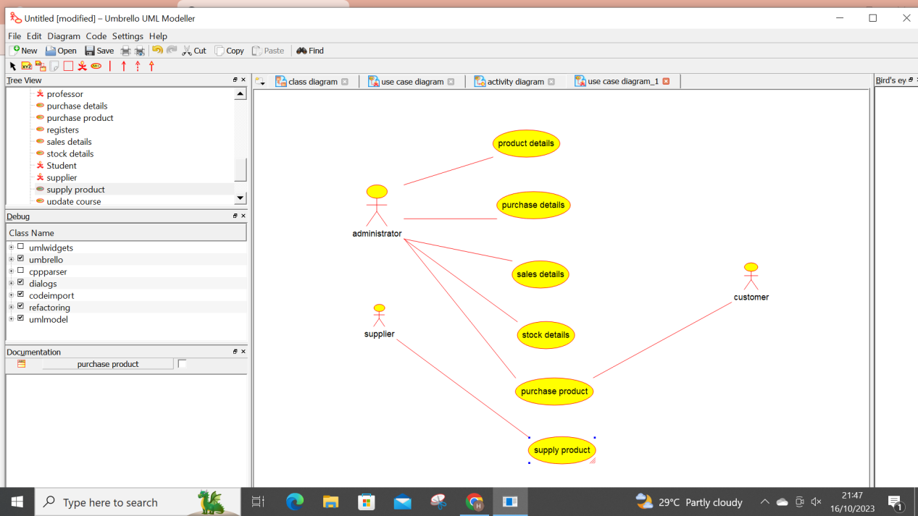

Activity diagram :

